2024 ORGANIZATIONAL MEETING
January 2, 2024
Jerry given oath
ROLL CALL
Trustees Donald Barto
Jerry Mayfield Mark Schuster

Fiscal Officer Michele Nowakowski

Township Administrator Leo Brittson

Department Heads fire department
Chief Kaiser/police
Chad Klavinger/roads

Nomination for chairperson and vice chairperson
Executive Session:
Per ORC 121.22(G)1 to consider employment of a public employee
ZONING APPOINTMENTS
Nominations for Zoning alternate replacing Jerry 1 yr term
Nomination for Zoning appeals

MOTIONS
Administrative office hours
Schedule for regular monthly board meetings Quarterly financial meetings
Purchase orders and blanket certificates to $50,000
Payroll dates for elected officials Payroll fund for elected officials
Payroll split for TA and EOA positions
Split for shared invoices Split for interest payments Paid observed holidays
Govdeals blanket motion Approval of new contracts

FEDERAL HOLIDAYS 11 OF THEM:

Washingtons birthday is presidents day

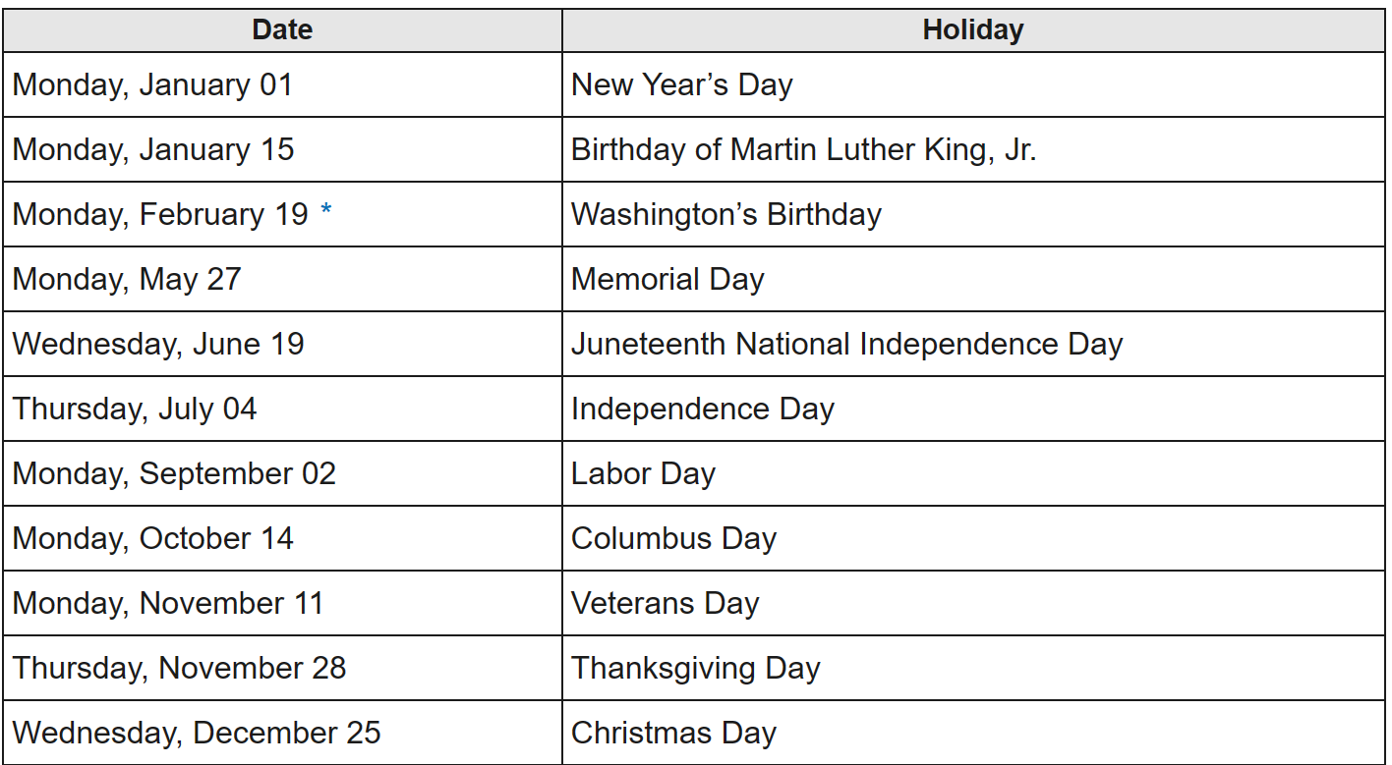

Adjourn meeting

